SQL CODING CHALLENGE

**GIVEN:**

1. Vehicle Table:

• vehicleID (Primary Key)

• make

• model

• year

• dailyRate

• status (available, notAvailable)

• passengerCapacity

• engineCapacity

2. Customer Table:

• customerID (Primary Key)

• firstName

• lastName

• email

• phoneNumber

3. Lease Table:

• leaseID (Primary Key)

• vehicleID (Foreign Key referencing Vehicle Table)

• customerID (Foreign Key referencing Customer Table)

• startDate

• endDate

• type (to distinguish between DailyLease and MonthlyLease)

4. Payment Table:

• paymentID (Primary Key)

• leaseID (Foreign Key referencing Lease Table)

• paymentDate

• amount

CREATE DATABASE carrent;

USE carrent;

CREATE TABLE Vehicle (

carID INT PRIMARY KEY,

make VARCHAR(50),

model VARCHAR(50),

year INT,

dailyRate DECIMAL(6,2),

available BOOLEAN,

passengerCapacity INT,

engineCapacity INT

);

CREATE TABLE Customer (

customerID INT PRIMARY KEY,

firstName VARCHAR(50),

lastName VARCHAR(50),

email VARCHAR(100),

phoneNumber VARCHAR(20)

);

CREATE TABLE Lease (

leaseID INT PRIMARY KEY,

carID INT,

customerID INT,

startDate DATE,

endDate DATE,

leaseType VARCHAR(20),

FOREIGN KEY (carID) REFERENCES Vehicle(carID),

FOREIGN KEY (customerID) REFERENCES Customer(customerID)

);

CREATE TABLE Payment (

paymentID INT PRIMARY KEY,

leaseID INT,

transactionDate DATE,

amount DECIMAL(8,2),

FOREIGN KEY (leaseID) REFERENCES Lease(leaseID)

);

INSERT INTO Vehicle VALUES

(1, 'Toyota', 'Camry', 2022, 50.00, 1, 4, 1450),

(2, 'Honda', 'Civic', 2023, 45.00, 1, 7, 1500),

(3, 'Ford', 'Focus', 2022, 48.00, 0, 4, 1400),

(4, 'Nissan', 'Altima', 2025, 52.00, 1, 7, 1200),

(5, 'Chevrolet', 'Malibu', 2022, 47.00, 1, 4, 1800),

(6, 'Hyundai', 'Sonata', 2025, 49.00, 0, 7, 1400),

(7, 'BMW', '3 Series', 2024, 60.00, 1, 7, 2499),

(8, 'Mercedes', 'C-Class', 2022, 58.00, 1, 8, 2599),

(9, 'Audi', 'A4', 2022, 55.00, 0, 4, 2500),

(10, 'Lexus', 'ES', 2023, 54.00, 1, 4, 2500);

INSERT INTO Customer VALUES

(1, 'John', 'Doe', 'johndoe@example.com', '555-555-5555'),

(2, 'Jane', 'Smith', 'janesmith@example.com', '555-123-4567'),

(3, 'Robert', 'Johnson', 'robert@example.com', '555-789-1234'),

(4, 'Sarah', 'Brown', 'sarah@example.com', '555-456-7890'),

(5, 'David', 'Lee', 'david@example.com', '555-987-6543'),

(6, 'Laura', 'Hall', 'laura@example.com', '555-234-5678'),

(7, 'Michael', 'Davis', 'michael@example.com', '555-876-5432'),

(8, 'Emma', 'Wilson', 'emma@example.com', '555-432-1098'),

(9, 'William', 'Taylor', 'william@example.com', '555-321-6547'),

(10, 'Olivia', 'Adams', 'olivia@example.com', '555-765-4321');

INSERT INTO Lease VALUES

(1, 1, 1, '2023-01-01', '2023-01-05', 'Daily'),

(2, 2, 2, '2023-02-15', '2023-02-28', 'Monthly'),

(3, 3, 3, '2023-03-10', '2023-03-15', 'Daily'),

(4, 4, 4, '2025-04-20', '2025-04-30', 'Monthly'),

(5, 5, 5, '2024-05-05', '2024-05-10', 'Daily'),

(6, 4, 3, '2023-06-15', '2023-06-30', 'Monthly'),

(7, 7, 7, '2024-07-01', '2024-07-10', 'Daily'),

(8, 8, 8, '2023-08-12', '2023-08-15', 'Monthly'),

(9, 3, 3, '2025-06-19', '2025-06-22', 'Daily'),

(10, 10, 10, '2023-10-10', '2023-10-31', 'Monthly');

INSERT INTO Lease VALUES

(14, 3, 4, '2025-06-17', '2025-06-22', 'Daily');

INSERT INTO Payment VALUES

(1, 1, '2023-01-03', 200.00),

(2, 2, '2023-02-20', 1000.00),

(3, 3, '2023-03-12', 75.00),

(4, 4, '2024-04-25', 900.00),

(5, 5, '2024-05-07', 60.00),

(6, 6, '2021-06-18', 1200.00),

(7, 7, '2023-07-03', 40.00),

(8, 8, '2023-08-14', 1100.00),

(9, 9, '2025-06-19', 80.00),

(10, 10, '2025-10-25', 1500.00);

INSERT INTO Payment VALUES

(14,14,'2025-06-18',1600.00);

1. 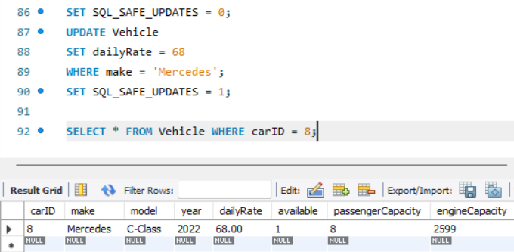**Update the daily rate for a Mercedes car to 68.**

SET SQL_SAFE_UPDATES = 0;

UPDATE Vehicle

SET dailyRate = 68

WHERE make = 'Mercedes';

SET SQL_SAFE_UPDATES = 1;

**2. Delete a specific customer and all associated leases and payments.**

DELETE FROM Payment

WHERE leaseID IN (SELECT leaseID FROM Lease WHERE customerID = 3);

DELETE FROM Lease

WHERE customerID = 3;

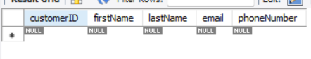DELETE FROM Customer

WHERE customerID = 3;

SELECT * FROM Payment

WHERE leaseID IN (SELECT leaseID FROM Lease WHERE customerID = 3);

SELECT * FROM Lease

WHERE customerID = 3;

SELECT * FROM Customer

WHERE customerID = 3;

**3. Rename the "paymentDate" column in the Payment table to "transactionDate".**

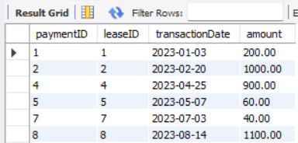ALTER TABLE Payment

CHANGE paymentDate transactionDate DATE;

SELECT paymentID, leaseID, transactionDate, amount

FROM Payment;

**4. Find a specific customer by email.**

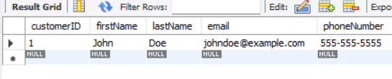SELECT * FROM Customer

WHERE email = 'johndoe@example.com'

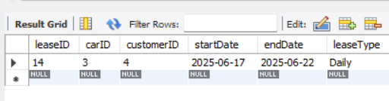**5. Get active leases for a specific customer.**

SELECT * FROM Lease

WHERE customerID = 4

AND CURDATE() BETWEEN startDate AND endDate;

**6. Find all payments made by a customer with a specific phone number.**

SELECT P.paymentID, P.leaseID, P.transactionDate, P.amount

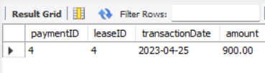FROM Payment P

JOIN Lease L ON P.leaseID = L.leaseID

JOIN Customer C ON L.customerID = C.customerID

WHERE C.phoneNumber = '555-456-7890';

**7. Calculate the average daily rate of all available cars.**

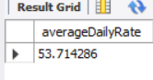SELECT AVG(dailyRate) AS averageDailyRate

FROM Vehicle

WHERE available = 1;

**8. Find the car with the highest daily rate.**

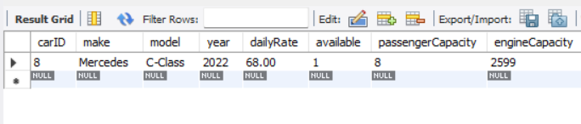SELECT *

FROM Vehicle

ORDER BY dailyRate DESC

LIMIT 1;

**9. Retrieve all cars leased by a specific customer.**

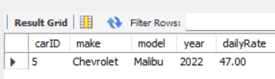SELECT V.carID, V.make, V.model, V.year, V.dailyRate

FROM Vehicle V

JOIN Lease L ON V.carID = L.carID

WHERE L.customerID = 5;

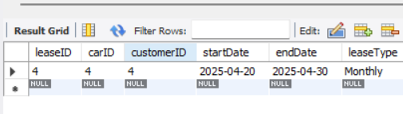**10. Find the details of the most recent lease.**

SELECT *

FROM Lease

ORDER BY endDate DESC

LIMIT 1;

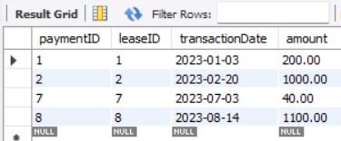**11. List all payments made in the year 2023.**

SELECT *

FROM Payment

WHERE YEAR(transactionDate) = 2023;

**12. Retrieve customers who have not made any payments.**

SELECT *

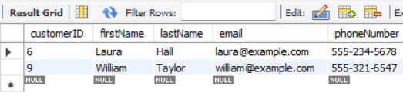FROM Customer

WHERE customerID NOT IN (

SELECT DISTINCT L.customerID

FROM Lease L

JOIN Payment P ON L.leaseID = P.leaseID

);

**13. Retrieve Car Details and Their Total Payments.**

SELECT

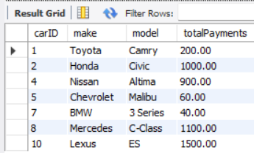 V.carID,

V.make,

V.model,

SUM(P.amount) AS totalPayments

FROM Vehicle V

JOIN Lease L ON V.carID = L.carID

JOIN Payment P ON L.leaseID = P.leaseID

GROUP BY V.carID, V.make, V.model;

**14. Calculate Total Payments for Each Customer.**

SELECT

C.customerID,

C.firstName,

C.lastName,

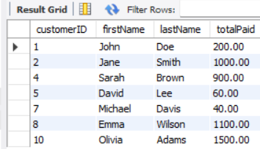 SUM(P.amount) AS totalPaid

FROM Customer C

JOIN Lease L ON C.customerID = L.customerID

JOIN Payment P ON L.leaseID = P.leaseID

GROUP BY C.customerID, C.firstName, C.lastName;

**15. List Car Details for Each Lease.**

SELECT L.leaseID,V.carID,V.make,V.model,V.year,

V.dailyRate,L.startDate,L.endDate,L.leaseType

FROM Lease L

JOIN Vehicle V ON L.carID = V.carID;

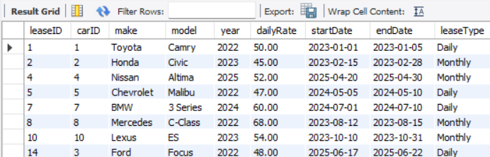

**16. Retrieve Details of Active Leases with Customer and Car Information.**

SELECT L.leaseID,C.customerID,C.firstName,C.lastName,

V.carID,V.make,V.model,V.year,L.startDate,

L.endDate,L.leaseType

FROM Lease L

JOIN Customer C ON L.customerID = C.customerID

JOIN Vehicle V ON L.carID = V.carID

WHERE '2025-06-19' BETWEEN L.startDate AND L.endDate;

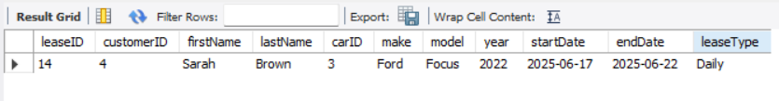

**17. Find the Customer Who Has Spent the Most on Leases.**

SELECT C.customerID,C.firstName,C.lastName,

SUM(P.amount) AS totalSpent

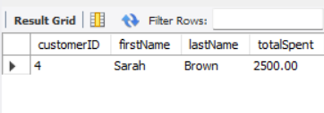FROM Customer C

JOIN Lease L ON C.customerID = L.customerID

JOIN Payment P ON L.leaseID = P.leaseID

GROUP BY C.customerID, C.firstName, C.lastName

ORDER BY totalSpent DESC

LIMIT 1;

**18. List All Cars with Their Current Lease Information.**

SELECT V.carID,V.make,V.model,V.year,L.leaseID,L.startDate,

L.endDate,C.customerID,C.firstName,C.lastName

FROM Vehicle V

LEFT JOIN Lease L

ON V.carID = L.carID AND CURDATE() BETWEEN L.startDate AND L.endDate

LEFT JOIN Customer C

ON L.customerID = C.customerID;

